Course-End Project: Sales Analysis

Project Statement:
AAL is a household name in Australia, known for its clothing business since 2000. It caters to all groups— kids, women, men, and seniors. It has opened branches in many states in Australia, in metropolises and tier-1 and tier-2 cities.
The business is booming, and the company is in an expansion mode. It wants to get an in-depth understanding of its sales so that it can make investment decisions. The CEO has tasked the Head of Sales and Marketing (S&M) of AAL to:
- Determine the states that are generating the highest revenues and
- Formulate sales programs for states with lower revenues. The Head of S&M has approached you for the same.
Analyze the company’s sales data for the fourth quarter across Australia, and state by state and help the company make data-driven decisions for the coming year.

Perform the following steps:
As a data scientist, you must perform the following main steps on the enclosed data.
- Data Wrangling
- Data Analysis
- Data Visualization and
- Report Generation
- Data Wrangling
- Ensure that the data is clean and that there is no missing or incorrect data.
  - Inspect the data manually for missing/incorrect data using the functions isna(), and notna().
- Based on your knowledge of Data Analytics, include your recommendations for treating missing data and incorrect data. (dropping the null values or filling them).
- Select an appropriate Data Wrangling approach — data standardization or data normalization. Perform the standardization or normalization and present the data. (Normalization is the preferred approach for this problem.)
- Share your recommendation on the usage of the groupby() function for data chunking or merging.
- Data Analysis
- Perform descriptive statistical analysis on the data (Sales and Unit columns) (Techniques such as mean, median, mode and standard deviation can be used.).
- Determine which group is generating the highest sales, and which group is generating the lowest sales.
- Determine which state is generating the highest sales, and which state is generating the lowest sales.
- Generate weekly, monthly and quarterly reports for the analysis made.
(Use suitable libraries such as NumPy, Pandas, SciPy etc. for performing the analysis.)
- Data Visualization
- Use appropriate data visualization libraries to build a dashboard for the Head of S&M that includes for the key parameters like
  - State-wise sales analysis for different groups (kids, women, men, and seniors)
  - Group-wise sales analysis (kids, women, men, and seniors) across different states.
  - Time-of-the-day analysis: during which time of the day are sales the highest, and during which time are sales the lowest? [This helps S&M teams design programs for increasing sales such as hyper-personalization and Next Best Offers].
The dashboard must contain daily, weekly, monthly and quarterly charts.
(Any visualization library can be used for this purpose. However, since statistical analysis is being done, Seaborn is preferred.)
- Include your recommendation, and indicate why you are choosing the recommended visualization package.
- Report Generation
- Use JupyterLab Notebook for report generation (wrangling, analysis and visualization) Please note that JupyterLab allows you to mix code with graphs and plots etc.
- Use Markdown in suitable places, while presenting your report.
- The report should contain suitable graphs, plots and analysis reports, and recommendations. Please note that different aspects of analysis demand different graphs/plots.
  - Use box plot for descriptive statistics
  - Use Seaborn distribution plot for any other statistical plotting.

Code in Jupyter:
Data Wrangling :
import pandas as pd
import numpy as np

# Load the dataset
file_path = "C:/bh010/!!BH File 1/Sales Analysis Class 4/Sales.csv"
df = pd.read_csv("Sales.csv")

print("Number of missing values:")
print(df.isna().sum())

# We'll use Min-Max normalization for simplicity.

def min_max_normalization(x):
return (x - x.min()) / (x.max() - x.min())

df['Unit_normalized'] = min_max_normalization(df['Unit'])
df['Sales_normalized'] = min_max_normalization(df['Sales'])

# Let's drop the original 'Unit' and 'Sales' columns as they are no longer needed.
df.drop(columns=['Unit', 'Sales'], inplace=True)

# Total sales by 'State'
total_sales_by_state = df.groupby('State')['Sales_normalized'].sum()
print("\nTotal sales by State:")
print(total_sales_by_state)

# Total sales by 'Group'
total_sales_by_group = df.groupby('Group')['Sales_normalized'].sum()
print("\nTotal sales by Group:")
print(total_sales_by_group)

# Saving the cleaned and normalized data to a new CSV file
df.to_csv("data1.csv", index=False)

Output:

Number of missing values:
Date 0
Time 0
State 0
Group 0
Unit 0
Sales 0
dtype: int64

Total sales by State:
State
NSW 441.714286
NT 109.079365
QLD 177.888889
SA 339.412698
TAS 110.222222
VIC 635.968254
WA 106.365079
Name: Sales_normalized, dtype: float64

Total sales by Group:
Group
Kids 480.142857
Men 484.444444
Seniors 473.571429
Women 482.492063
Name: Sales_normalized, dtype: float64

Also cleaned_normalized_data.csv

Data Analysis:
import pandas as pd

# Load the dataset
df = pd.read_csv("Sales.csv")

# Descriptive statistical analysis on 'Sales' and 'Unit' columns
sales_stats = df[['Sales', 'Unit']].describe()
print("Descriptive Statistical Analysis:")
print(sales_stats)

# Determine which group is generating the highest and lowest sales
group_sales = df.groupby('Group')['Sales'].sum()
highest_group_sales = group_sales.idxmax()
lowest_group_sales = group_sales.idxmin()
print("\nGroup generating the highest sales:", highest_group_sales)
print("Group generating the lowest sales:", lowest_group_sales)

# Determine which state is generating the highest and lowest sales
state_sales = df.groupby('State')['Sales'].sum()
highest_state_sales = state_sales.idxmax()
lowest_state_sales = state_sales.idxmin()
print("\nState generating the highest sales:", highest_state_sales)
print("State generating the lowest sales:", lowest_state_sales)

# Generate weekly, monthly, and quarterly reports for the analysis made
df['Date'] = pd.to_datetime(df['Date']) # Convert 'Date' column to datetime
df.set_index('Date', inplace=True) # Set 'Date' column as index

# Weekly report
weekly_report = df.resample('W').sum()
print("\nWeekly Report:")
print(weekly_report)

# Monthly report
monthly_report = df.resample('M').sum()
print("\nMonthly Report:")
print(monthly_report)

# Quarterly report
quarterly_report = df.resample('Q').sum()
print("\nQuarterly Report:")
print(quarterly_report)

Output:

Descriptive Statistical Analysis:
Sales Unit
count 7560.000000 7560.000000
mean 45013.558201 18.005423
std 32253.506944 12.901403
min 5000.000000 2.000000
25% 20000.000000 8.000000
50% 35000.000000 14.000000
75% 65000.000000 26.000000
max 162500.000000 65.000000

Group generating the highest sales: Men
Group generating the lowest sales: Seniors

State generating the highest sales: VIC
State generating the lowest sales: WA

Weekly Report:
Time \
Date
2020-10-04 Morning Morning Morning Morning Afternoon Aft...
2020-10-11 Morning Morning Morning Morning Afternoon Aft...
2020-10-18 Morning Morning Morning Morning Afternoon Aft...
2020-10-25 Morning Morning Morning Morning Afternoon Aft...
2020-11-01 Morning Morning Morning Morning Afternoon Aft...
2020-11-08 Morning Morning Morning Morning Afternoon Aft...
2020-11-15 Morning Morning Morning Morning Afternoon Aft...
2020-11-22 Morning Morning Morning Morning Afternoon Aft...
2020-11-29 Morning Morning Morning Morning Afternoon Aft...
2020-12-06 Morning Morning Morning Morning Afternoon Aft...
2020-12-13 Morning Morning Morning Morning Afternoon Aft...
2020-12-20 Morning Morning Morning Morning Afternoon Aft...
2020-12-27 Morning Morning Morning Morning Afternoon Aft...
2021-01-03 Morning Morning Morning Morning Afternoon Aft...

State \
Date
2020-10-04 WA WA WA WA WA WA WA WA WA WA WA WA NT NT NT ...
2020-10-11 WA WA WA WA WA WA WA WA WA WA WA WA NT NT NT ...
2020-10-18 WA WA WA WA WA WA WA WA WA WA WA WA NT NT NT ...
2020-10-25 WA WA WA WA WA WA WA WA WA WA WA WA NT NT NT ...
2020-11-01 WA WA WA WA WA WA WA WA WA WA WA WA NT NT NT ...
2020-11-08 WA WA WA WA WA WA WA WA WA WA WA WA NT NT NT ...
2020-11-15 WA WA WA WA WA WA WA WA WA WA WA WA NT NT NT ...
2020-11-22 WA WA WA WA WA WA WA WA WA WA WA WA NT NT NT ...
2020-11-29 WA WA WA WA WA WA WA WA WA WA WA WA NT NT NT ...
2020-12-06 WA WA WA WA WA WA WA WA WA WA WA WA NT NT NT ...
2020-12-13 WA WA WA WA WA WA WA WA WA WA WA WA NT NT NT ...
2020-12-20 WA WA WA WA WA WA WA WA WA WA WA WA NT NT NT ...
2020-12-27 WA WA WA WA WA WA WA WA WA WA WA WA NT NT NT ...
2021-01-03 WA WA WA WA WA WA WA WA WA WA WA WA NT NT NT ...

Group Unit Sales
Date
2020-10-04 Kids Men Women Seniors Kids Men Women Seniors... 6018 15045000
2020-10-11 Kids Men Women Seniors Kids Men Women Seniors... 10801 27002500
2020-10-18 Kids Men Women Seniors Kids Men Women Seniors... 10656 26640000
2020-10-25 Kids Men Women Seniors Kids Men Women Seniors... 10726 26815000
2020-11-01 Kids Men Women Seniors Kids Men Women Seniors... 8723 21807500
2020-11-08 Kids Men Women Seniors Kids Men Women Seniors... 8346 20865000
2020-11-15 Kids Men Women Seniors Kids Men Women Seniors... 8469 21172500
2020-11-22 Kids Men Women Seniors Kids Men Women Seniors... 8445 21112500
2020-11-29 Kids Men Women Seniors Kids Men Women Seniors... 8591 21477500
2020-12-06 Kids Men Women Seniors Kids Men Women Seniors... 11849 29622500
2020-12-13 Kids Men Women Seniors Kids Men Women Seniors... 12610 31525000
2020-12-20 Kids Men Women Seniors Kids Men Women Seniors... 12662 31655000
2020-12-27 Kids Men Women Seniors Kids Men Women Seniors... 12708 31770000
2021-01-03 Kids Men Women Seniors Kids Men Women Seniors... 5517 13792500

Monthly Report:
Time \
Date
2020-10-31 Morning Morning Morning Morning Afternoon Aft...
2020-11-30 Morning Morning Morning Morning Afternoon Aft...
2020-12-31 Morning Morning Morning Morning Afternoon Aft...

State \
Date
2020-10-31 WA WA WA WA WA WA WA WA WA WA WA WA NT NT NT ...
2020-11-30 WA WA WA WA WA WA WA WA WA WA WA WA NT NT NT ...
2020-12-31 WA WA WA WA WA WA WA WA WA WA WA WA NT NT NT ...

Group Unit \
Date
2020-10-31 Kids Men Women Seniors Kids Men Women Seniors... 45716
2020-11-30 Kids Men Women Seniors Kids Men Women Seniors... 36273
2020-12-31 Kids Men Women Seniors Kids Men Women Seniors... 54132

Sales
Date
2020-10-31 114290000
2020-11-30 90682500
2020-12-31 135330000

Quarterly Report:
Time \
Date
2020-12-31 Morning Morning Morning Morning Afternoon Aft...

State \
Date
2020-12-31 WA WA WA WA WA WA WA WA WA WA WA WA NT NT NT ...

Group Unit \
Date
2020-12-31 Kids Men Women Seniors Kids Men Women Seniors... 136121

Sales
Date
2020-12-31 340302500

Data Visualization:

import pandas as pd
import seaborn as sns
import matplotlib.pyplot as plt

# Load the dataset
df = pd.read_csv("Sales.csv")

# Convert 'Date' column to datetime
df['Date'] = pd.to_datetime(df['Date'])

# State-wise sales analysis for different groups
plt.figure(figsize=(12, 6))
sns.barplot(data=df, x='State', y='Sales', hue='Group', ci=None)
plt.title('State-wise Sales Analysis for Different Groups')
plt.xlabel('State')
plt.ylabel('Sales')
plt.legend(title='Group')
plt.show()

# Group-wise sales analysis across different states
plt.figure(figsize=(12, 6))
sns.barplot(data=df, x='Group', y='Sales', hue='State', ci=None)
plt.title('Group-wise Sales Analysis Across Different States')
plt.xlabel('Group')
plt.ylabel('Sales')
plt.legend(title='State')
plt.show()

# Time-of-the-day analysis
time_sales = df.groupby('Time')['Sales'].sum().reset_index()
time_sales = time_sales.sort_values(by='Sales', ascending=False)

plt.figure(figsize=(10, 6))
sns.barplot(data=time_sales, x='Time', y='Sales', ci=None)
plt.title('Time-of-the-day Analysis')
plt.xlabel('Time of the Day')
plt.ylabel('Sales')
plt.show()

# Weekly charts
weekly_sales = df.resample('W', on='Date')['Sales'].sum().reset_index()

plt.figure(figsize=(12, 6))
sns.lineplot(data=weekly_sales, x='Date', y='Sales', marker='o')
plt.title('Weekly Sales')
plt.xlabel('Date')
plt.ylabel('Sales')
plt.show()

# Monthly charts
monthly_sales = df.resample('M', on='Date')['Sales'].sum().reset_index()

plt.figure(figsize=(12, 6))
sns.lineplot(data=monthly_sales, x='Date', y='Sales', marker='o')
plt.title('Monthly Sales')
plt.xlabel('Date')
plt.ylabel('Sales')
plt.show()

# Quarterly charts
quarterly_sales = df.resample('Q', on='Date')['Sales'].sum().reset_index()

plt.figure(figsize=(12, 6))
sns.lineplot(data=quarterly_sales, x='Date', y='Sales', marker='o')
plt.title('Quarterly Sales')
plt.xlabel('Date')
plt.ylabel('Sales')
plt.show()

Output:
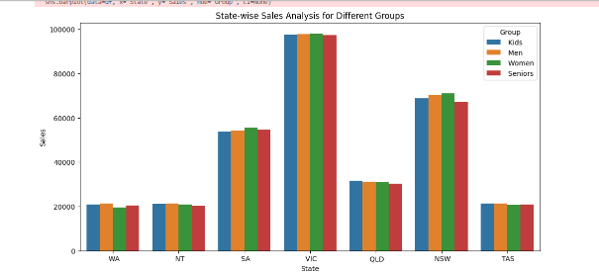
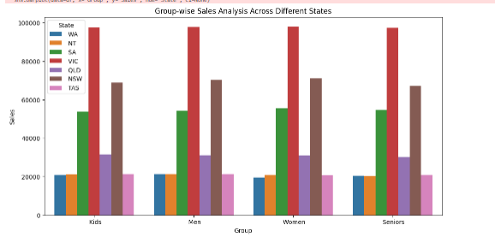
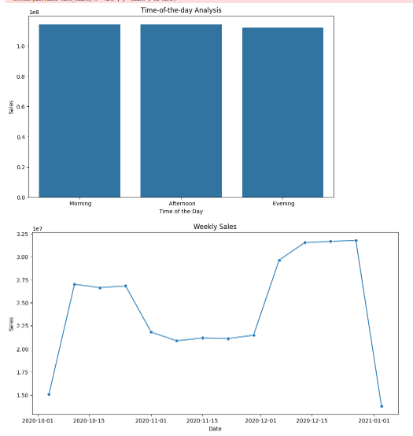

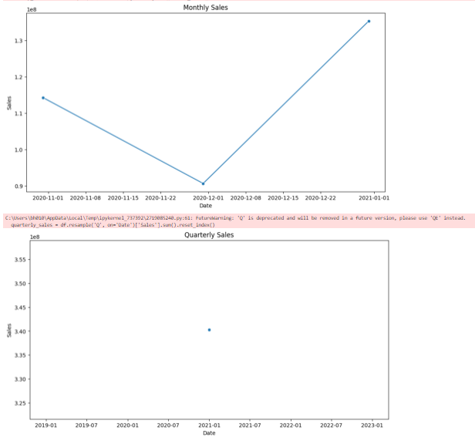

Report:

import pandas as pd
import seaborn as sns
import matplotlib.pyplot as plt

# Load the dataset
file_path = "your_file_path_here.csv" # Replace "your_file_path_here.csv" with the actual path to your CSV file
df = pd.read_csv("Sales.csv")

# Convert 'Date' column to datetime
df['Date'] = pd.to_datetime(df['Date'])

# Markdown for Report Introduction
"""
# Sales Analysis Report

This report presents an analysis of sales data for a specific period. We'll perform data wrangling, analysis, and visualization to gain insights into sales performance.

"""

# Data Wrangling Section
"""

""".format(df.shape, df.columns.tolist(), df.dtypes, df.isnull().sum())

# Descriptive Statistical Analysis Section
"""
## Descriptive Statistical Analysis

### Sales and Unit Columns

#### Summary Statistics:
{}
""".format(df[['Sales', 'Unit']].describe())

# Box Plot for Sales and Unit Columns
plt.figure(figsize=(10, 6))
sns.boxplot(data=df[['Sales', 'Unit']])
plt.title('Box Plot for Sales and Unit Columns')
plt.xlabel('Columns')
plt.ylabel('Values')
plt.show()

# Recommendations for Descriptive Statistics
"""

"""

# Data Visualization Section
"""

"""

# State-wise Sales Analysis for Different Groups
plt.figure(figsize=(12, 6))
sns.barplot(data=df, x='State', y='Sales', hue='Group', ci=None)
plt.title('State-wise Sales Analysis for Different Groups')
plt.xlabel('State')
plt.ylabel('Sales')
plt.legend(title='Group')
plt.show()

Output:

